- Three histograms

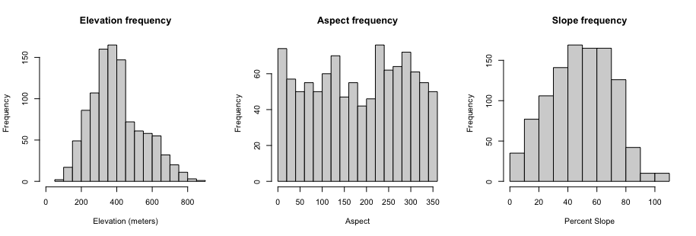

- The elevation histogram graphs the frequency of elevational ranges that each point count was conducted at. The distribution of the histogram has a bell-like shape, left-skewed: there are lower frequencies at each end of the scale, and a higher frequency in the center. This means that the surveys/point counts were conducted along an elevational gradient, from 0m to 1000m or so, but the most common elevation surveyed was between 350-450m. Survey sites above 450m were more equally surveyed than sites below 350m; there was close to an equal sample size of sites at 500, 550, 600, and 650m, and relatively few sites above 650m. Below 350m, there were an increasing number of sites surveyed, with low elevation being the least represented.
- Percent slope (rise over run x 100)
- The slope histogram graphs the frequency of slope ranges that each point count was conducted at. The distribution, similar to the elevational frequency, has a bell-shaped curve, slightly right-skewed. Most of the sites surved fall near the median, which for a scale 0-110% is 55%. There are not many flat sites represented, nor many extremely steep sites surveyed, but there are a good number of medium-shallow sites, from 10-40%. This makes sense, as the surveys were done on the ground, and these slopes are easier to access and traverse than extremely steep sites. On the greater side of the median, there is less representation of very steep sites, especially over 80% slope.
- Aspect is the cardinal direction that a slope faces, and expressed in the dataset as a degree from 0-360. 0 or 360 degrees is north facing, 90 degrees is east facing, 180 is south, and 270 is west.
- The aspect histogram graphs the frequency of aspect that each point count was conducted at. The graph does not have a clear pattern to it, though it is not equally distributed among aspect degrees. Among the most represented in the dataset are north facing slopes (degree=0-25), southeast facing slopes (degree=125-150), southwest facnig slopes (degree=225-250), and generally west/northwest facing slopes (degree=270-325). There is clearly an effort by the surveyor to take survey points at different aspects – which usually are correlated to different habitat types, water availability, and species present because of the amount of sunlight they receive.

- 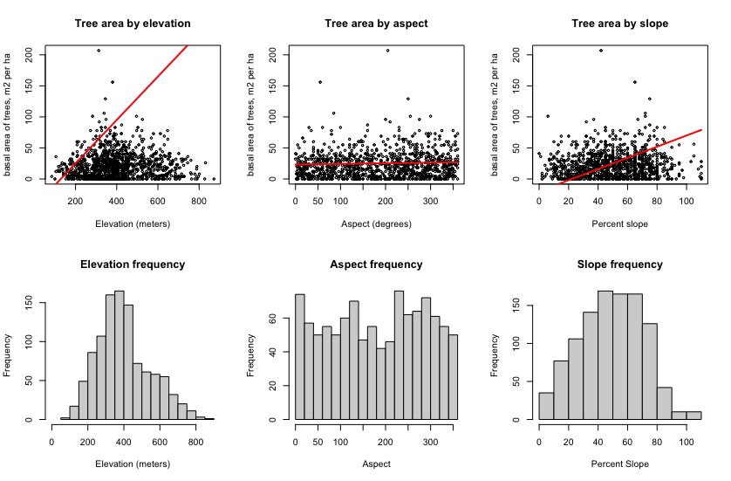

- For elevation, I was unable to make a good fitting line – the data doesn’t seem linear, though there is a slight monotonic distribution. Aspect and basal area seems to have no relationship, and again it’s a bad candidate for a linear model. Slope was perhaps a bit more correlated but still not a good linear fit.

